Data
The SleepDataset.zip file contains 27 csv files, with each file corresponding to a single night of data. The files have four columns: timestamp, Actiwatch activity counts, Actiware classification (1 for wake, 0 for sleep), and ENMO value calculated from the Apple Watch data. Each row corresponds to the data for a 15-second epoch. Dates have been modified to preserve privacy, with times unchanged.

Tasks
A number of participants wore two devices (Actiwatch and Apple Watch) on the same arm, typically for two successive nights.
Your objective is to try to perform sleep/wake classification for the Apple Watch, using the Actiwatch classification as the ground truth.
For the Apple Watch, we give you an ENMO (Euclidean Norm Minus One) value to summarise 15 seconds of acceleration data. For the Actiwatch, you have access to the "activity counts" for the same 15-second epoch (and to the sleep/wake classification).
You need to choose between two strategies:
- Trying to reproduce the activity counts, and then use the Philips classification algorithm.
- Work directly from the raw data to the classification with your own method.

The Philips’ Actiware software computes the total activity counts at epoch e using a weighted sum:
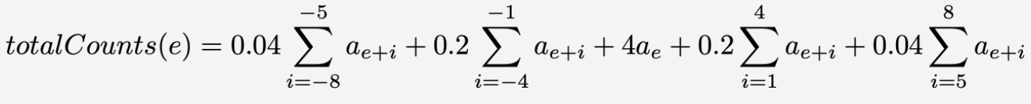
where a_{e} is the activity count of epoch e. Each epoch is classified as sleep if its total activity counts are less than or equal to a threshold; epochs with counts above the threshold are classified as wake. Common thresholds are 20 or 40.

Note: when using actigraphy, it is common to look for the first 5 minutes of uninterrupted sleep, and set all the epochs before that to wake, and then the last 5 minutes of uniterrupted sleep, and also set all the epochs after that to wake. You may want to do this as well.

